### ELITE DATAVERSE SOLUTIONS

### Homepage

* **Banner Image and video**
* **About Us Section**
* **Services Section**
* **Process Flow**
* **Team Section**
* **Contact Section**

### Services Page

* **Banner Image**
* **Overview**
* **List of Services**
* **Visuals**

### About Us Page

* **Banner Image**
* **Company Overview**
* **Mission and Values**
* **Team Members**
* **Visuals**

### Contact Us Page

* **Banner Image**
* **Contact Information**
* **Location Map**
* **Social Media Links**

|  |  |
| --- | --- |
| [globalts.com](https://www.globalts.com/" \o "https://www.globalts.com/) | Black-blue theme |

### Homepage

* **Banner Image and video**



|  |  |
| --- | --- |
| https://techspheresolutions.com/ | banner video |

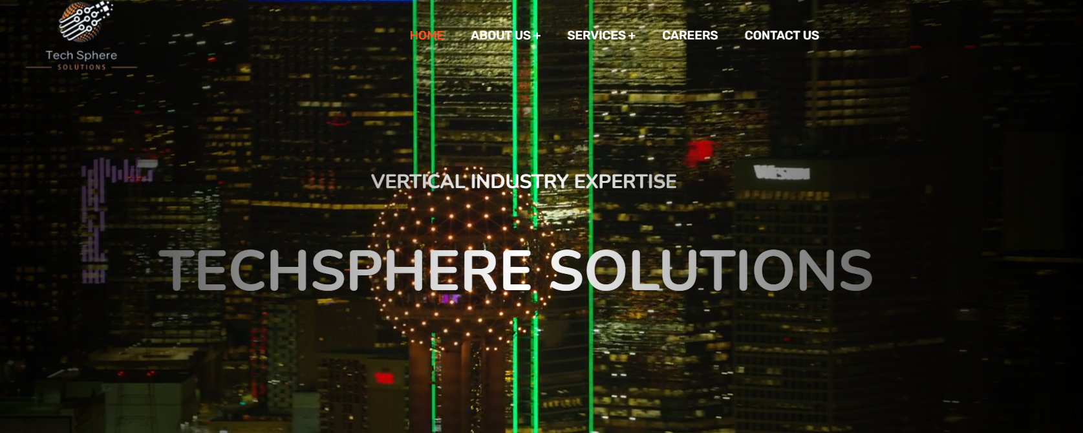

* **About Us Section**

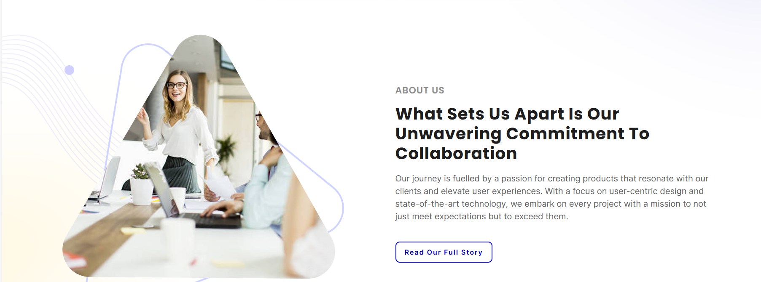

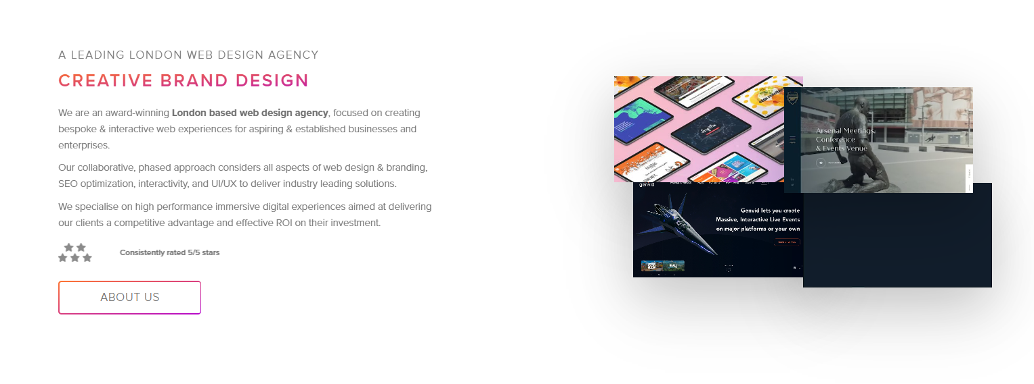

* **Services Section**

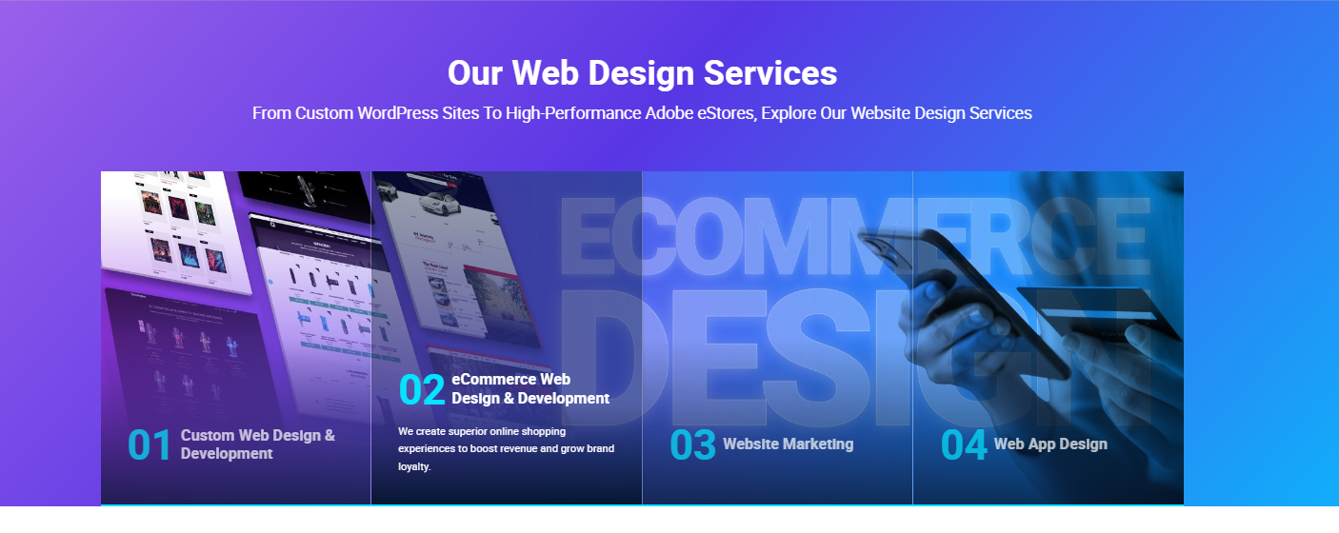

* **Process Flow**

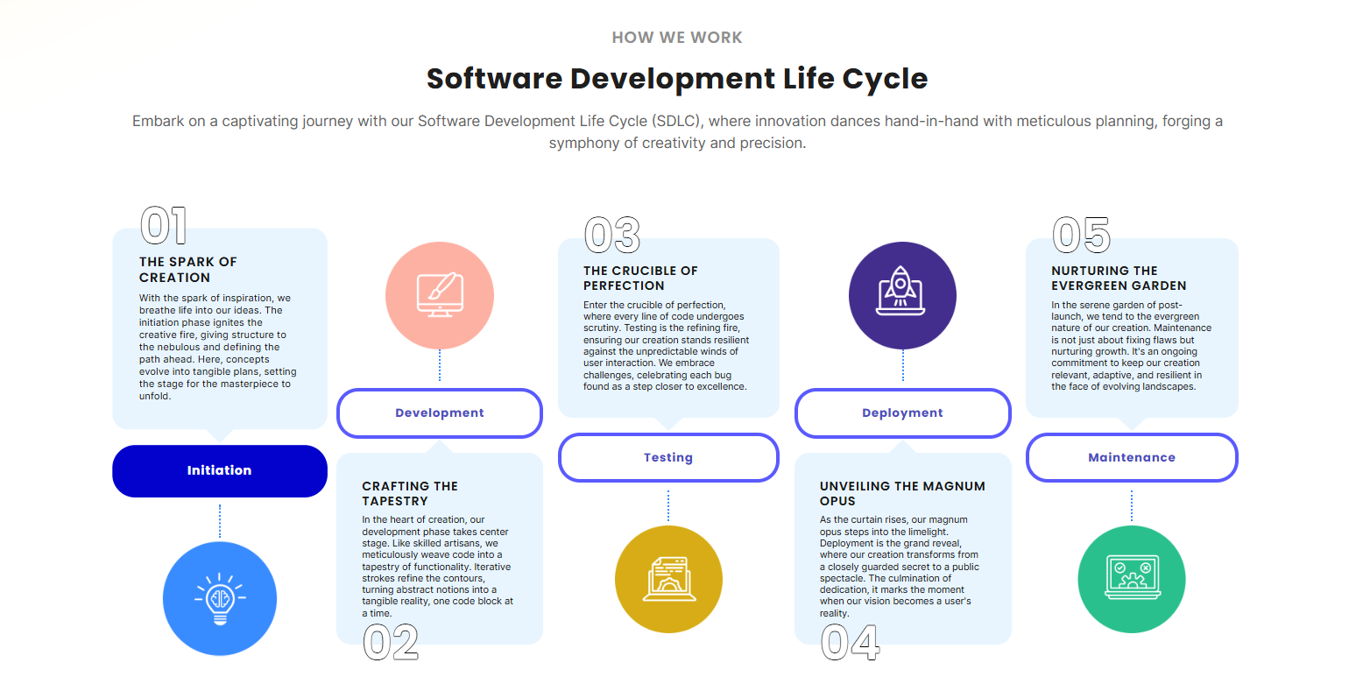

* **Team Section**

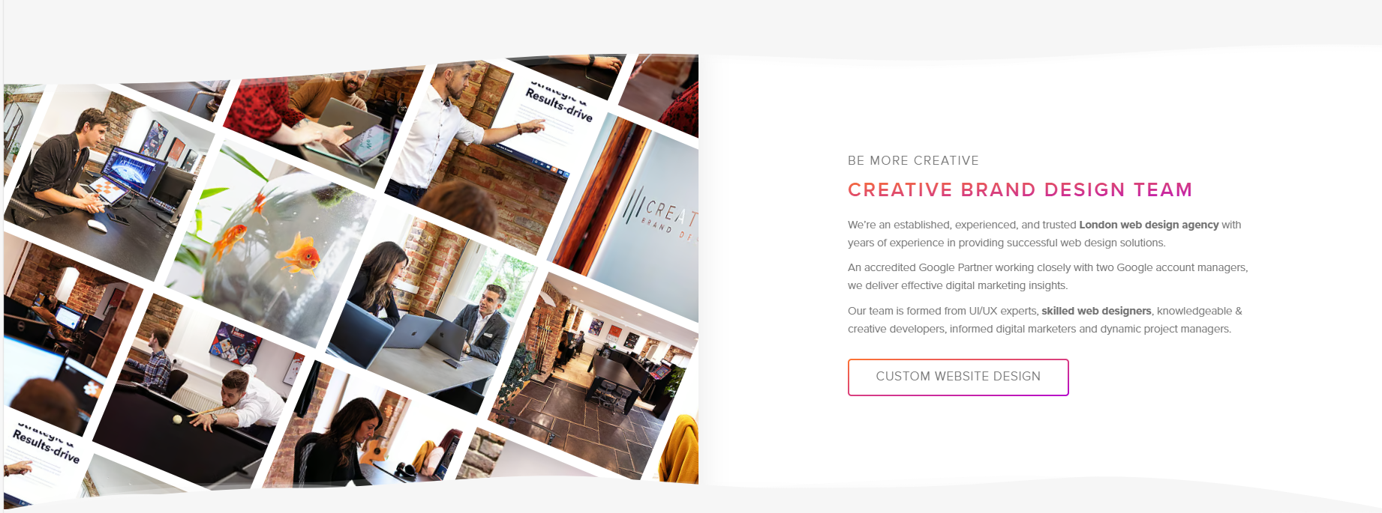

* **Contact Section**

|  |  |
| --- | --- |
| https://innovatetechsolutionsbest.com/ | contact page in home page |

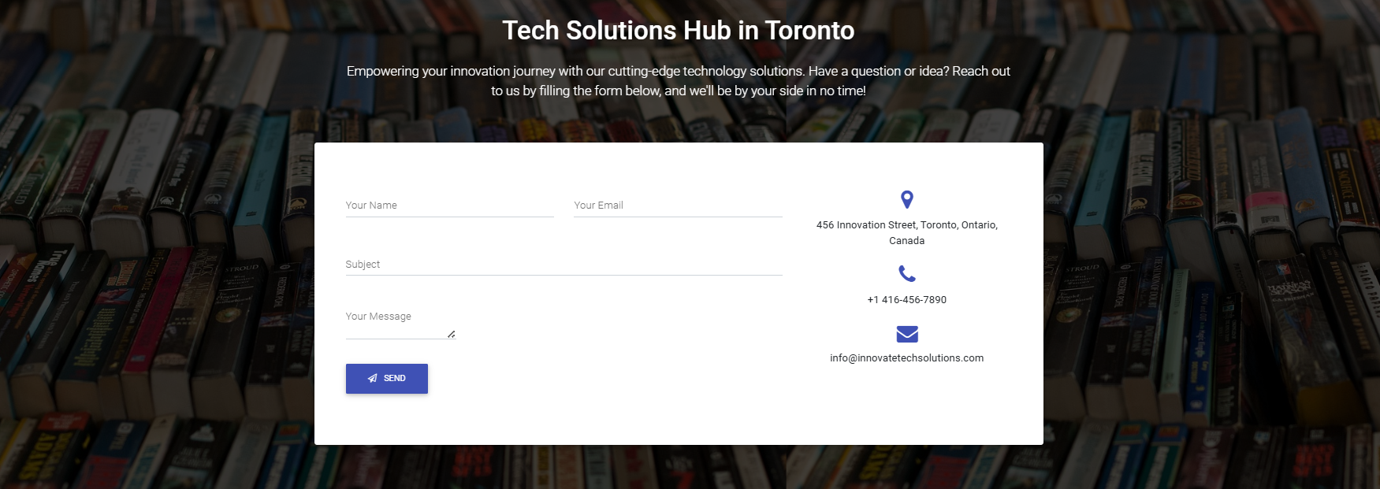

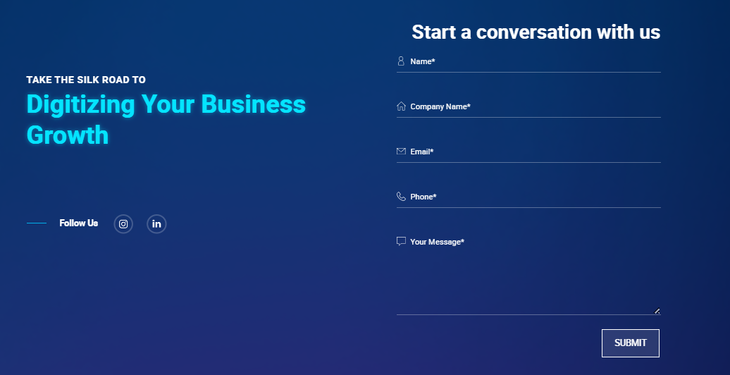

**Contact us page**

|  |  |
| --- | --- |
| Top Mobile App Development Company in India & USA - Konstantinfo | contact page |

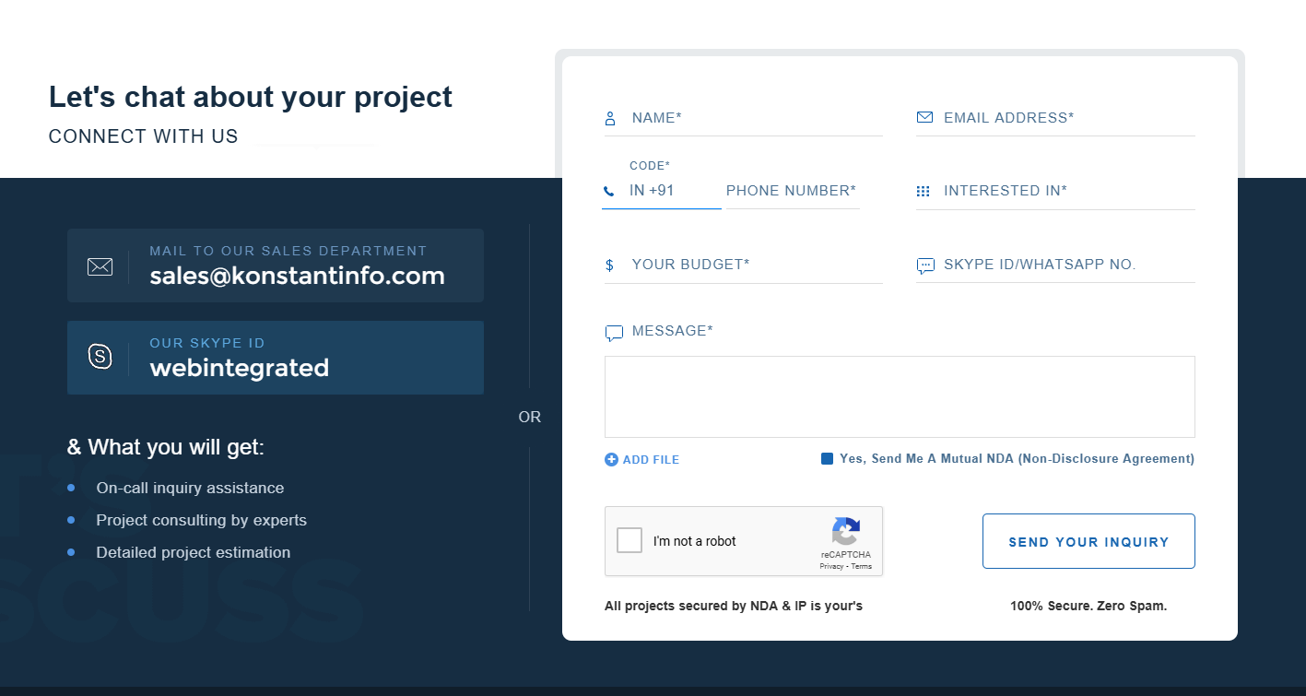

|  |  |
| --- | --- |
| [Contact Us | TechCraft Solutions (techcraftweb.in)](https://techcraftweb.in/contact.html" \o "https://techcraftweb.in/contact.html) | contact page |

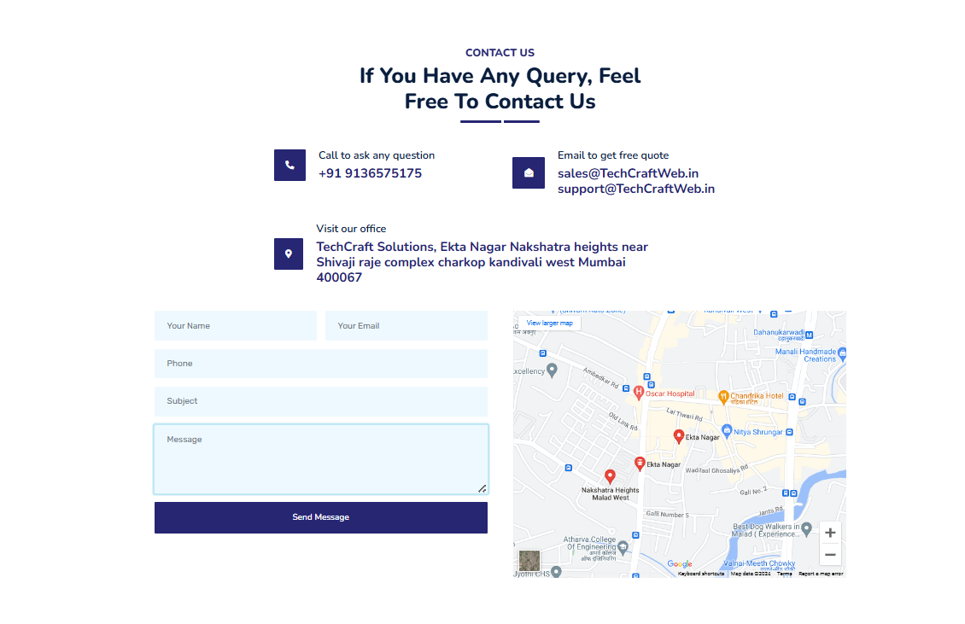

**About us ----> vision, mission, goals**

[Global Software Technologies (globaltechosoftware.com)](https://globaltechosoftware.com/)-



**Services page -----> list of services**

